|  |  |
| --- | --- |
| Course Name | ITD 2313 – Script Programming |
| Instructor | Mark Pranger |
| Student Name | Josh Jones |
| Due date | July 6 |
| Grade | <grade earned here> |
| Grading Comments | <instructor comments here> |

Page 136:

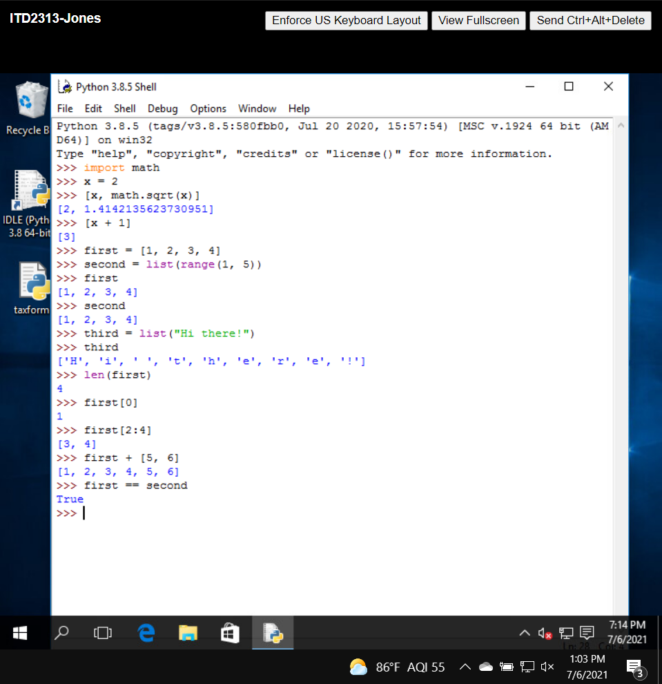

Page 137:

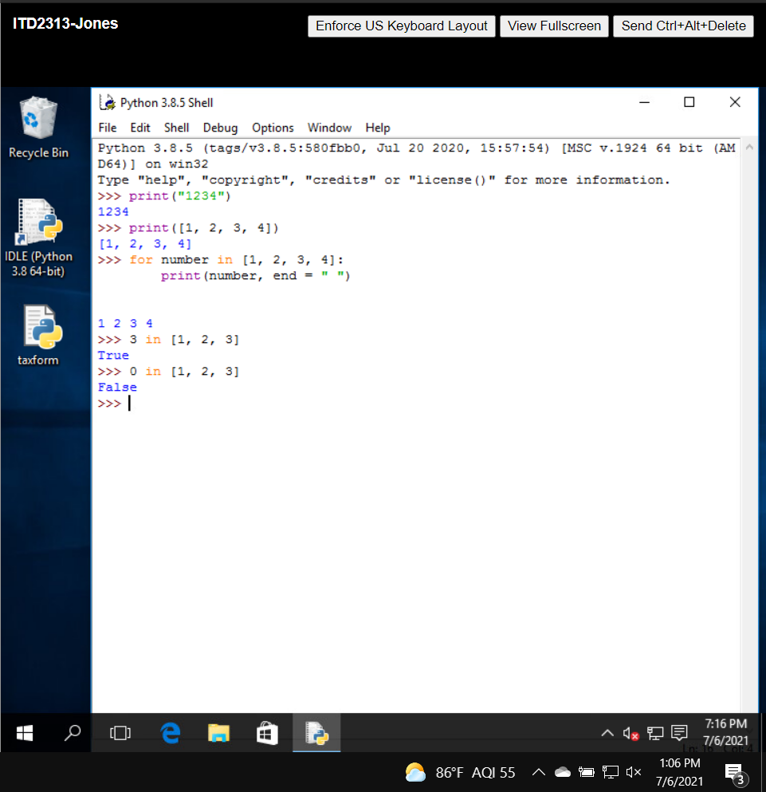

Page 138:

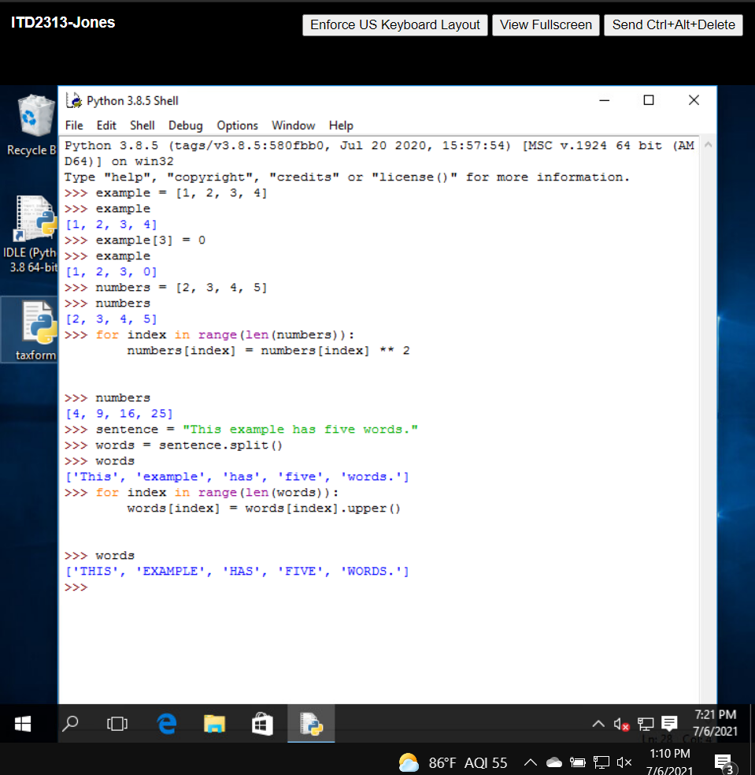

Page 139:

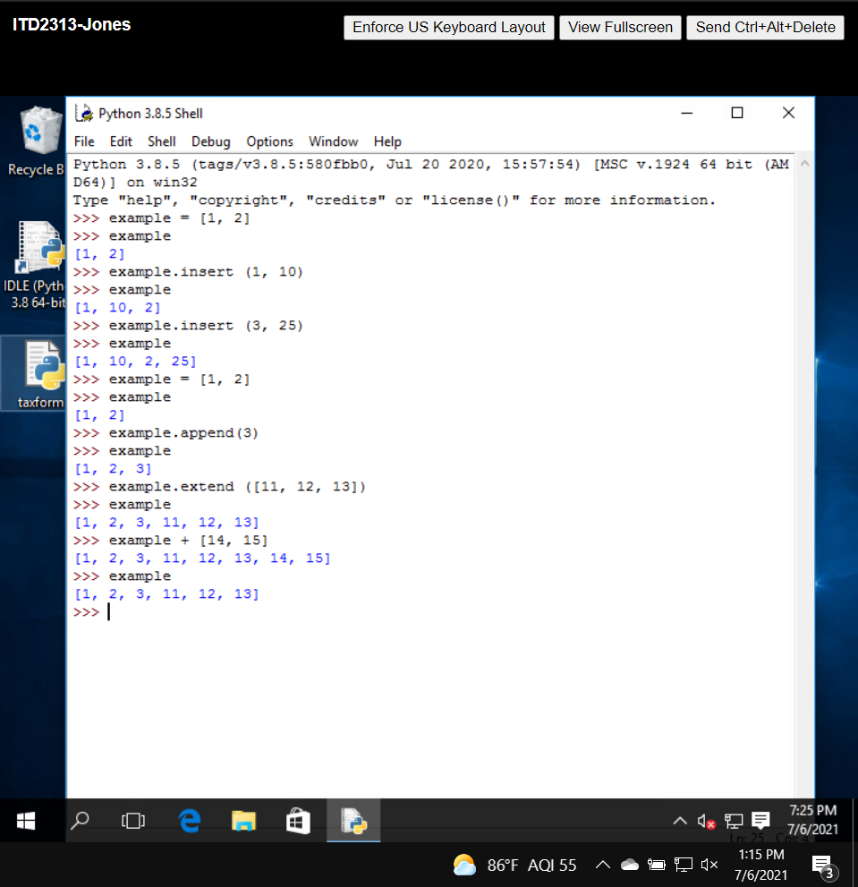

Page 140:

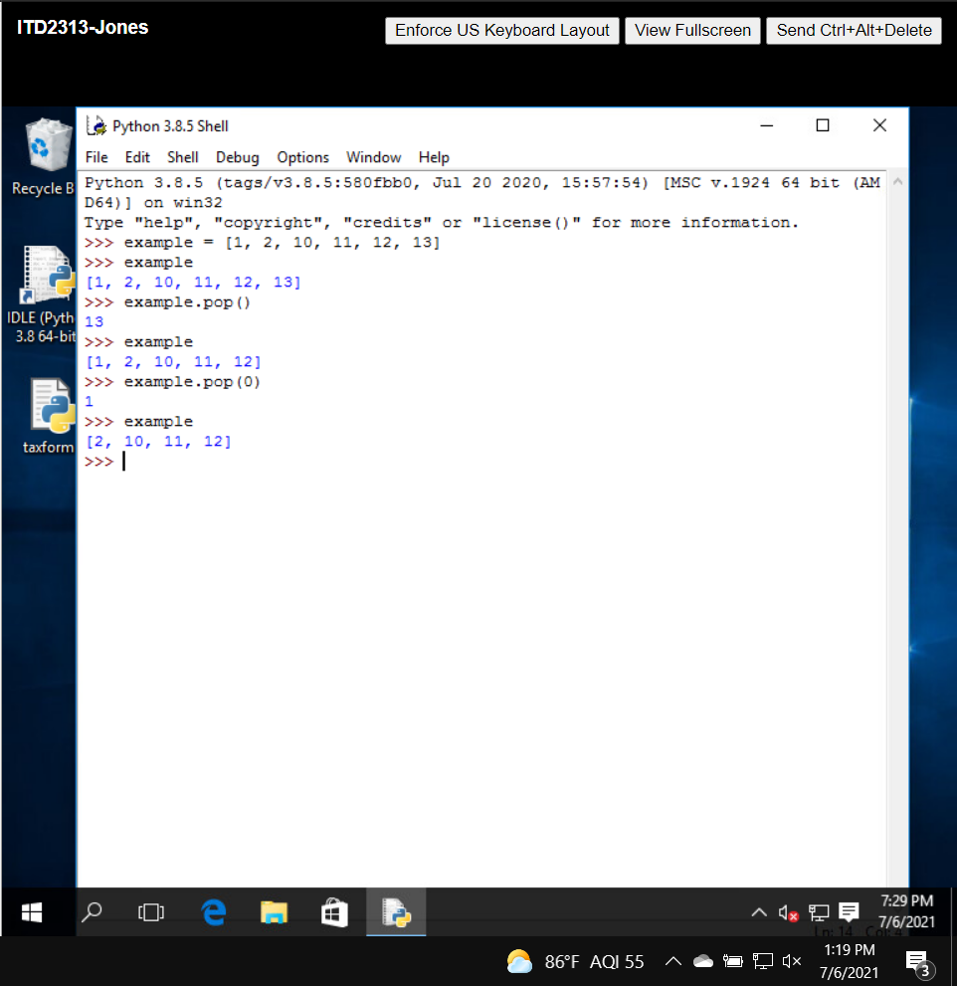

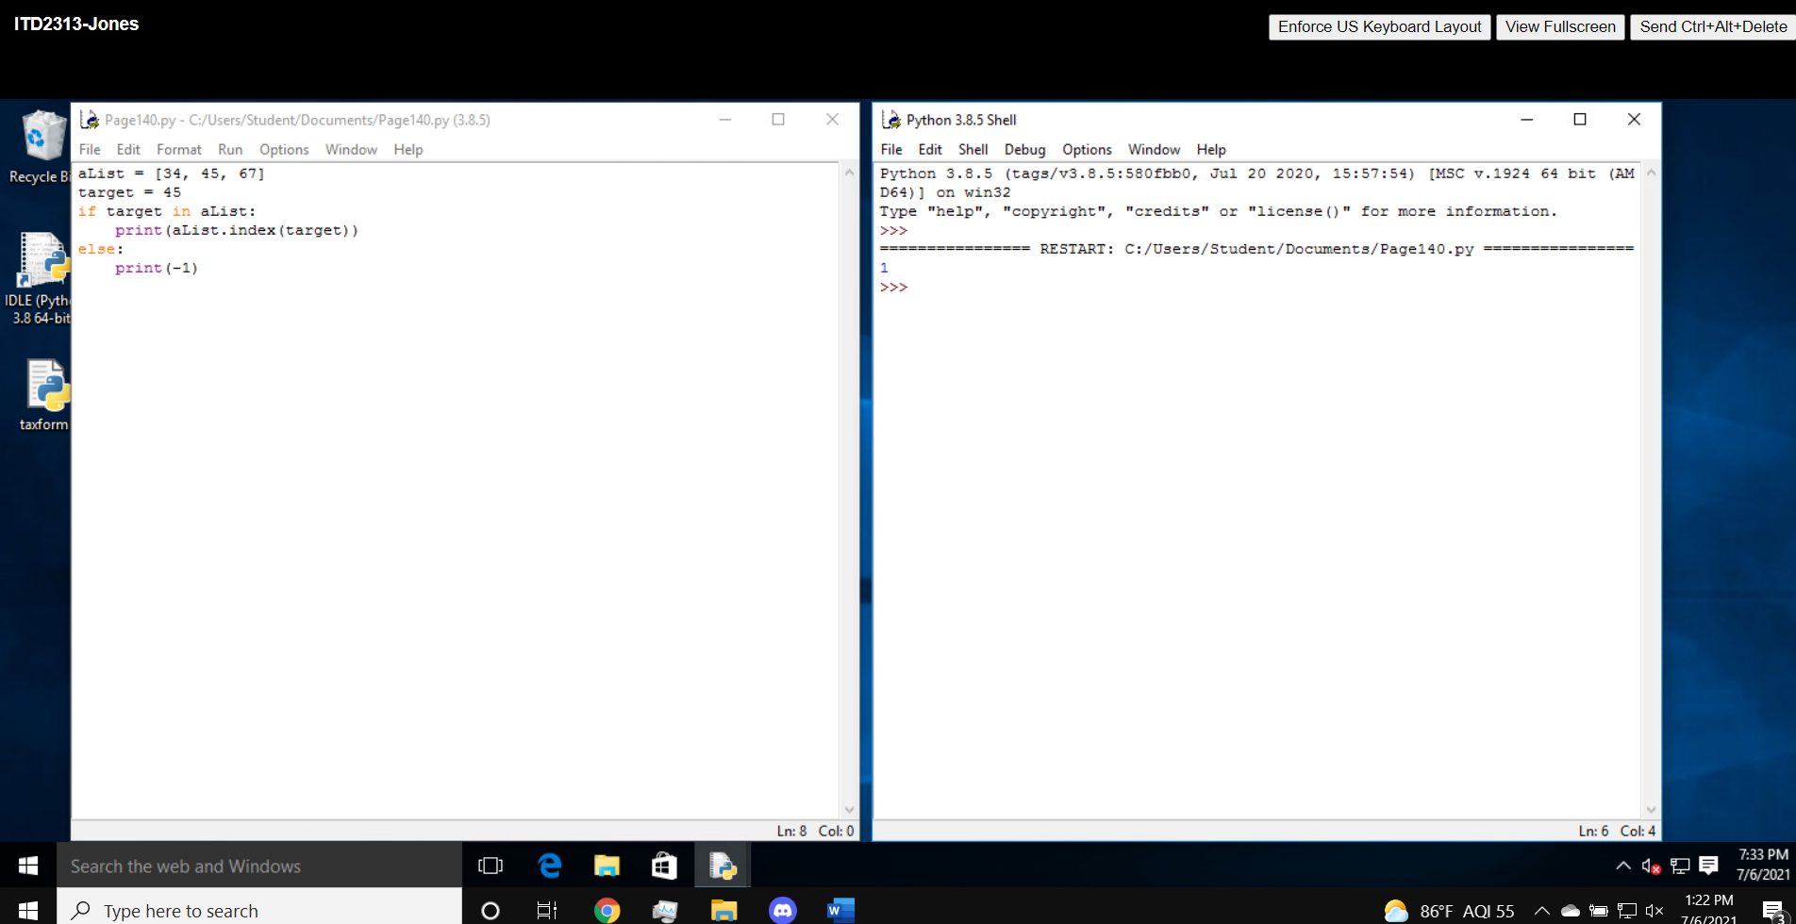

Page 141:

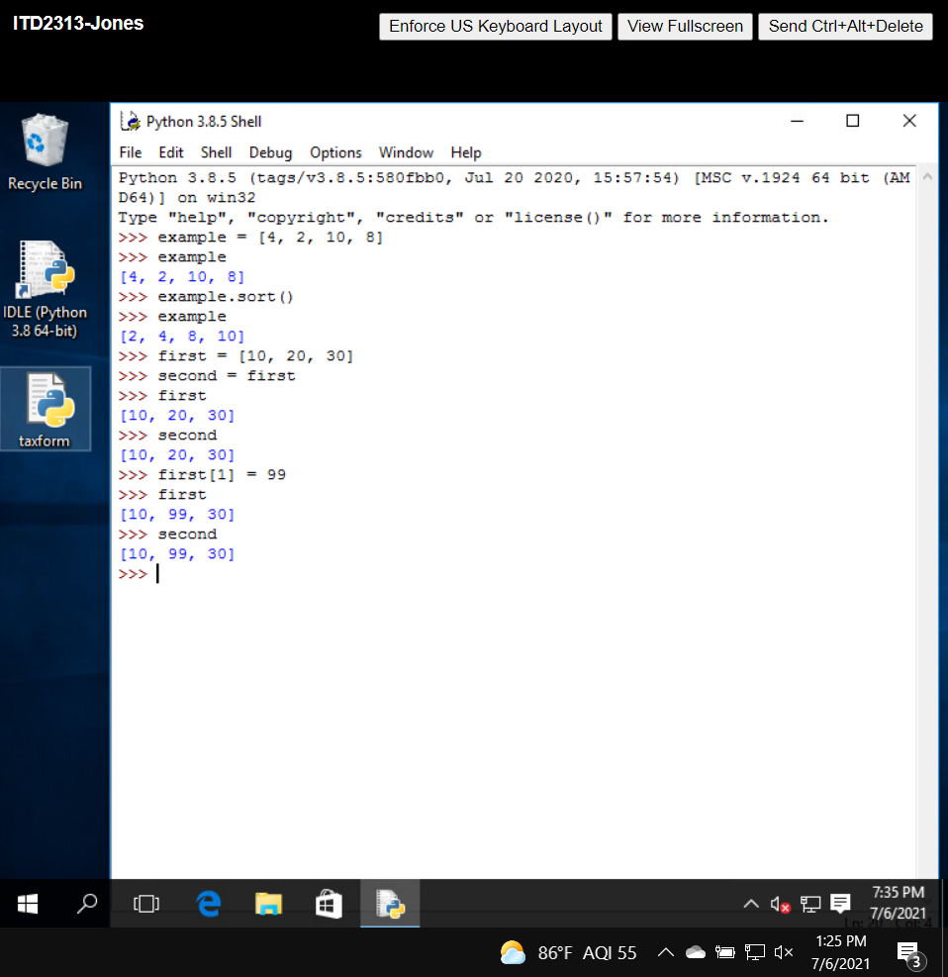

Page 143:

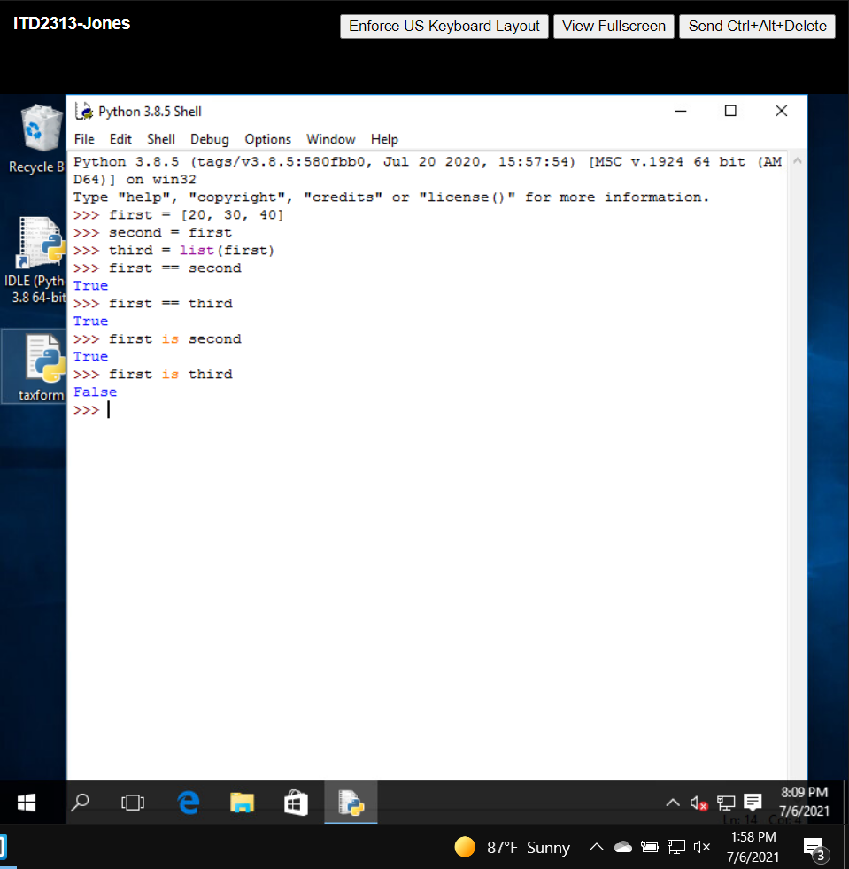

Page 144:

Page 145:

Page 146:

Page 147:

Page 148:

Page 149:

Page 154:

Page 155:

Page 156:

Page 157:

Page 158: